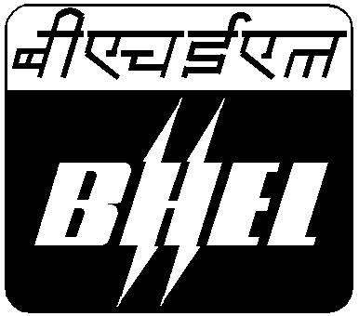
BHARAT HEAVY ELECTRICALS LIMITED
RAMACHANDRAPURAM :: HYDERABAD-502032
MAINTENANCE & SERVICES DIVISION
10-REPAIR SHOP, AIR-CONDITIONING

Phone : 040-23182554, 2759, Fax : 040-23020185, e-mail : ramapra@bhelhyd.co.in

Ref : HY/M&S/10-RS/RC/07-08/VRM-50/1019/21 Date : 19-10-2007

M/S …………………………….
………………………………….
………………………………….
…………………………………
…………………………………

Sir,

Sub : Reconditioning of MAS, CSSR make Portable Universal Radial Drilling machine
Type VRM-50 (Asset No.: 51-6028)—extension of due date to 27-10-07--intimation

Ref : Tender notice no. HY/M&S/10-RS/RC/07-08/VRM-50/1006/1 dt.06-10-2007

.-.-.-.-.-.-.

With reference to tender notice no. cited above for the subject work, this is to inform you that the due date of submission of your offer for this tender is extended to 27-10-2007. We invite your competitive participation for this tender. All other terms and conditions remains valid.

Thanking you,

Yours truly,

(K.RAMA PRASAD)
Sr.Manager (M&S)
10-Repair Shop, A.C.

