Bharat Heavy Electricals Limited
Ramachandrapuram :: Hyderabad – 32
Central Materials Management(Purchase-Rm)

Terms & Conditions

Ref: D2/08/Registration of vendors Dt.: 07.03.2009

Sub: Registration of vendors for Plates,Sheets,Structurals,Rounds & Pipes - Reg.

BHEL Hyderabad is engaged in the manufacture of Steam turbines, Gas turbines, Pulverisers , Oil rigs, Heat Exchangers, Generators, Switchgear etc.

For the products as above steel is the major input raw material and in order to meet the high performance requirement of the equipment in house specifications have been prepared. We invite suitable vendors to apply for registration as vendors for the specifications as listed in annexures for Plates,Sheets,Structurals,Rounds and Pipes.

To apply for registration, vendors who are interested may peruse the specifications and if able to meet the requirements may please log on to www.bhel.com and fill up the questionnaire. Two hard copies of the filled up questionnaire may please be forwarded to the undersigned for review and appraisal. Vendors who are already registered with BHEL Hyderabad need not apply for the specifications for which they are registered. Vendors who have applied but not yet registered can also apply.

Last date for receipt of application forms and filled up forms shall be 10.04.2009.

K.Prabhakar Dy.General Manager(Pur-Rm)

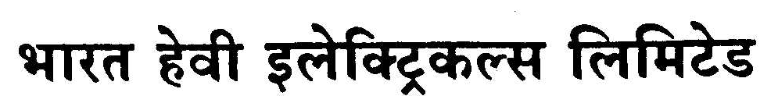

BHARAT HEAVY ELECTRICALS LIMITED
Heavy Power Equipment Plant,
Ramachandrapuram, Hyderabad – 500 032 (INDIA)

Fax:040-23021910/23021954
Purchase Department (Rm-Cmm)

Sub:- Registration of Vendors

BHEL Hyderabad invites application from suitable vendors to register as approved vendors for the supply of Plates,Sheets,Structurals,Rounds & Pipes.

For downloading details – Please visit BHEL website: www.bhel.com under Tender Notification.

Note: Availability of tender documents in website will be only up to penultimate day of due date. Any changes to this NIT will be published only in the above website.

K.Prabhakar
Dy.General Manager(Purchase-Rm)
e-mail: kprabhakar@bhelhyd.co.in
Tel.No.040-23185127/9490167844

